Tottenham Hotspur vs AFC Wimbledon
Emirates FA Cup 3rd Round Sunday 7th January 2018
If you want to be seated with a group of people please complete multiple forms and hand in together
Full Name: …………………………………………………………………………………………………………………………………………..
Address: ……………………………………………………………………………………………………………………………………………………………..………………………………………………………………………………………………………………Post Code….………………………..
Contact Number: ………………………………………………………………………………………………………………………………..
Email Address: …………………………………………………………………………………………………………………………………….
Ticket: Adults: £10 Concessions*: £5 (Please Tick Box, * Over 65, Students and U18)
Enter your membership number below:
Season Ticket Number: ……………………………… (Include Voucher A with form)
Dons Trust Member Number: ………………………………
Shareholder Number: ………………………………
Details of additional ticket holder:
Full Name: …………………………………………………………………………………………………………………………………………..
Address: ……………………………………………………………………………………………………………………………………………………………..………………………………………………………………………………………………………………Post Code….………………………..
Contact Number: ………………………………………………………………………………………………………………………………..
Email Address: …………………………………………………………………………………………………………………………………….
Ticket: Adults: £10 Concessions*: £5 (Please Tick Box, * Over 65, Students and U18)
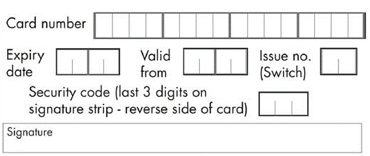

Please put all completed applications with correct
cash/card details in an envelope and hand in to the
office/complementary ticket window prior to the
Wigan Athletic match 3PM 16.12.17.

