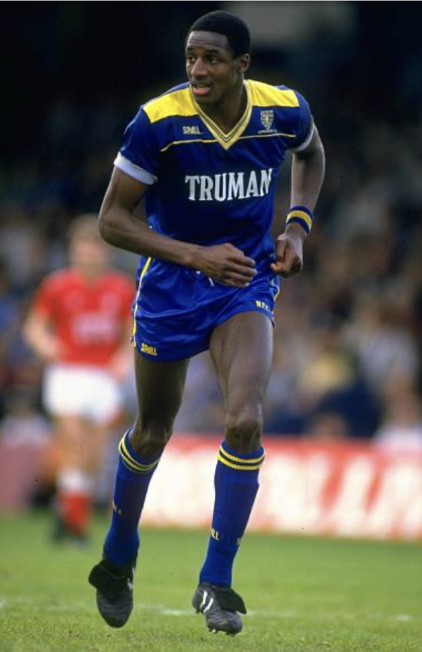
JOHN FASHANU - 319 GAMES – 136 GOALS - 2 INTERNATIONALS
Signed from Millwall for a club record at the time, £125,000, he was seen by then manager Dave Bassett as the final piece in the squad that would take the Dons to promotion to the top flight in May 1986. Fashanu’s 4 goals in 9 games proved the manager right.
For a number of years Fash became the media poster boy of Wimbledon FC, feared by defenders he earned the nickname ‘Fash the Bash’. In the Dons first season in the top division he hit 11 league goals and his goals in the 1987-88 season helped propel the Dons to the FA Cup Final at Wembley where Fashanu spearheaded the Dons attack. The goals continued and in May 1989 he became the first Wimbledon FC player to earn a full cap for England when he played against Chile at Wembley.
Along with Vinnie Jones, Fashanu embodied the ‘Wimbledon style of play’ but there was far more to his game than muscle and heading ability as those who travelled to Swindon and witnessed him chip the keeper from 35 yards can testify. He left the Dons in in 1994 to join Aston Villa but soon injuries forced his retirement. He then used his media profile and experience to become presenter of ‘Gladiators’ in the UK and ‘Deal or No Deal’ in Nigeria.

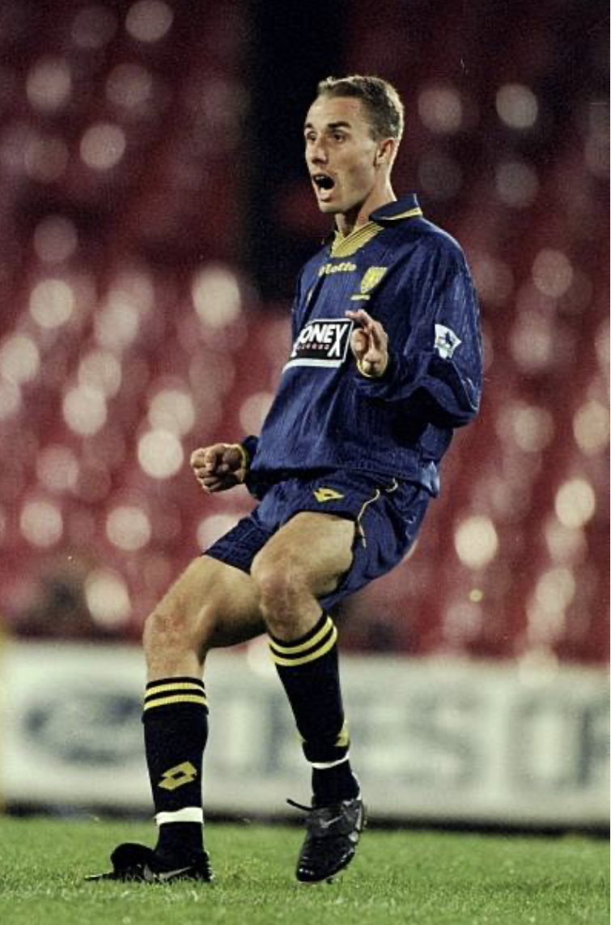
CHRIS PERRY - 212 GAMES – 3 GOALS
The epitome of ‘one of our own’. Chris Perry grew up a stone’s throw from Plough Lane and supported the club as a boy. He made over 200 league and cup appearances for the Dons and in the minds of most Wimbledon supporters at the time it was ridiculous that he was never selected for the national squad.
Perry was a master of man to man defending. A centre back whose strength was in the timing of the tackle. Only 5ft 9inches in height but able to compete with most strikers in the air. He earned the nickname ‘rash’ for being all over the player he was asked to mark. Before the beginning of the 1999-2000 season, Chris Perry joined Tottenham Hotspur for a then record club fee of £4million. In total he enjoyed an eighteen-year playing career at premier league and championship levels. Since retiring Chris was worked as a coach and currently offers match analysis on English and German football for radio stations.

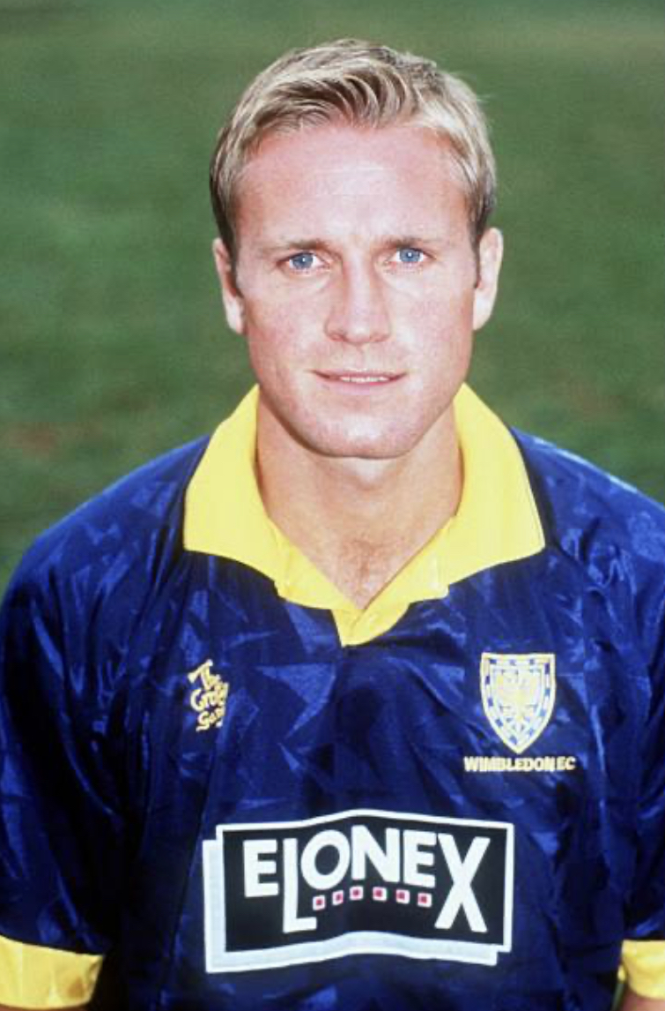
JOHN SCALES – 273 GAMES – 13 GOALS - 2 B INTERNATIONALS
When Bobby Gould arrived as Wimbledon manager in the summer of 1987 he began plundering the lower divisions for talent. One of his first buys was John Scales from Bristol Rovers. Within a year John Scales was accompanying Gould as they walked out on the Wembley turf for the 1988 Cup Final. Scales was a substitute that day alongside Laurie Cunningham. Scales was brought on , as fresh legs, late in the game to replace Terry Gibson. Although initially a right back, soon Scales was moved inside to centre back where over the years he had a variety of partners, Curle, Fitzgerald and Blackwell to name just three. Ever reliable John Scales made close to 300 league and cup appearances for the Dons over a seven year career.
In September 1994 he joined Liverpool where he collected a League Cup winners medal but perhaps more importantly three England caps. Late in his career he signed for Tottenham Hotspur but injuries were taking their toll and after a spell at Ipswich Town he retire from playing. John Scales has continued his involvement with the Dons being supportive of both AFC Wimbledon and ‘Fair Game’. He can occasionally be heard as part of commentary teams on Five Live.

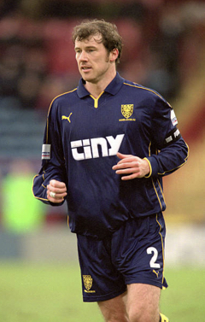
KENNY CUNNINGHAM - 306 GAMES – 0 GOALS - 48 INTERNATIONALS
Born in Dublin, he was scouted by Millwall in 1989. During a five year spell with the Lions he made the right back slot his own. In November 1994 Wimbledon manager Joe Kinnear wishing to strength his squad signed Cunningham and his Millwall teammate Jon Goodman for a combined fee of £1.3 million.
Over the next eight years Kenny Cunningham was a regular in the Dons side. Initially playing at right back, Cunningham was also comfortable playing at centre back. The disintegration of Wimbledon FC led to Cunningham moving to Birmingham City for a modest fee. He distinguished himself there but could not prevented the Blues being relegated. He moved on to Sunderland where he was united with Irish compatriots Niall Quinn (Chairman) and Roy Keane (manager). Injuries restricted him and he retired at the end of the season. Cunningham won 72 caps for the Republic of Ireland before retiring from international football in 2005 and since retiring from playing is a regular commentator of Irish Tv and radio.

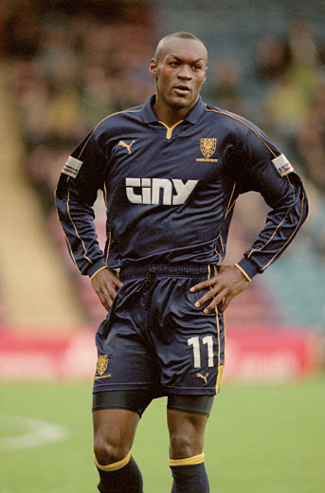
MARCUS GAYLE – 309 GAMES – 47 GOALS – 18 INTERNATIONALS
Born in London, Marcus Gayle began his football career at Brentford in 1998. Within a couple of years, he’d established himself as a first team squad member. Gayle joined the Dons during the 93-94 season and operated either wide on the left or as one of a two man striker force. Without the doubt his most memorable goal came against Manchester United in an FA Cup replay at Selhurst Park. His powerful header saw the Dons go through to the next round in February 1997. Gayle’s form brought him to the eye of Jamaica and he went on to represent them in the 1998 World Cup in France . Marcus Gayle stayed with the Dons through the turbulent 1999-2000 season but eventually moved to Rangers in March 2001.
Spells at Watford, Brentford and Aldershot Town followed before Marcus returned to bring down the curtain on his career back at the Dons. His last game being the Ryman Play Off final against Staines. Having helped the Dons gain promotion he fittingly celebrated with the supporters that night at Kingsmeadow. Today he is a club ambassador at Brentford and recently appeared on Sky Sports as match analyst as Brentford played Bournemouth.

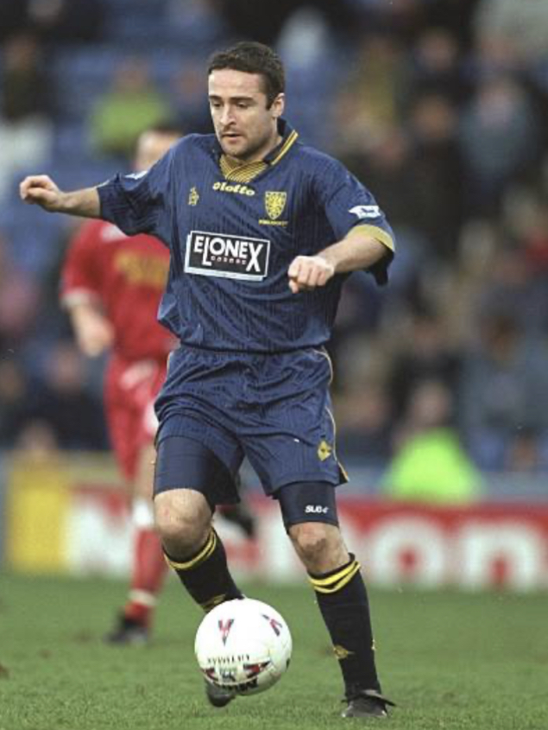
MICHAEL HUGHES 112 GAMES – 17 GOALS - 41 INTERNATIONALS
Michael Hughes was a well-established player well before joining the Dons from West Ham. After playing for Carrick in Ireland, Hughes joined Manchester City and then had a spell in France with Strasbourg before West Ham secured his services. In 1997 manager Joe Kinnear signed Hughes for £1.6 million and soon became a firm fans favourite. Sadly the departure of Kinnear saw Hughes somewhat ignored by new manager Egil Olsen, much to the amazement of Dons fans. In the 1999-2000 season that saw the Dons relegated from the Premiership, Hughes made just 13 league appearances.
The departure of Olsen saw Hughes restored to the starting line up and in the following two seasons while there was nothing to cheer about off the field at Wimbledon, Hughes tricky and dribbling skills brought some relief. Hughes left the Dons in March 2002 having play over a hundred league games. A move to Crystal Palace and then to Coventry City followed. At international level Michael Hughes was a regular for Northern Ireland for thirteen seasons amassing 71 caps. On retirement Hughes eventually settled back in Northern Ireland where he initially returned to his first club Carrick Rangers as manager. However today he can be found in the boardroom as chief Executive and co-owner of the club.

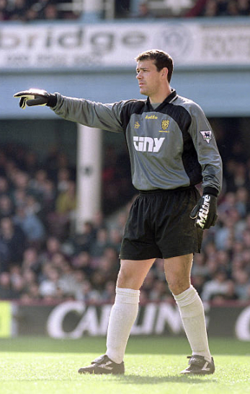
NEIL SULLIVAN – 247 GAMES – 0 GOALS – 19 INTERNATIONALS
Neil Sullivan rose through the youth team ranks at the Dons, then was understudy to Hans Segers, before making the goalkeeping journey his own. A career of over ten years saw him recognised as one of the most reliable keepers in the Premiership. Saves were greeted by Dons fans with a chorus of ‘Sully,Sully,Sully’. In spite of being voted the goalkeeper in the 1997-98 premiership team of the season, the football world continued to recognise him as the keeper who was beaten when a young David Beckham scored from the half way line at Selhurst Park in 1996. Wimbledon’s relegation from the Premiership inevitably led to him leaving the club. He signed for Tottenham Hotspur. After three seasons he left for Chelsea and then travelled to Leeds & Doncaster.
Despite being born in Sutton, Sully’s Scottish heritage allowed him to represent Scotland 28 times and in 1998 he went as part of their squad to the World Cup. In 2012 Neil Sullivan returned to Wimbledon on a short term loan and debuted for AFC Wimbledon against Aldershot in the Conference. He joined an elite group of players who have played for both Wimbledon FC and AFC Wimbledon. After retiring from playing Sully was become a specialist goalkeeping coach working both at Leeds United and Hull City.

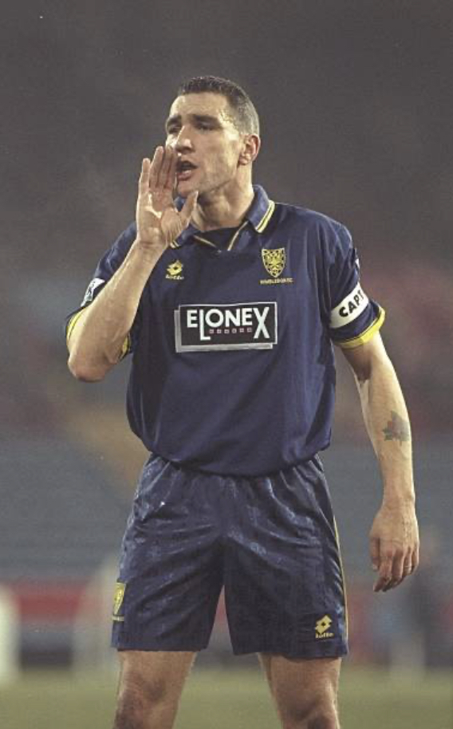
VINNIE JONES - 304 GAMES – 23 GOALS – 9 INTERNATIONALS
The name Vinnie Jones is synonymous with Wimbledon FC, they became interlocked even though Jones had spells with Leeds United, Sheffield United and Chelsea. In the autumn of 1986 Wimbledon paid non-league Wealdstone £10,000 for Jones who was at that time a part-time player who worked by day on building sites. In the stuff more suited to childrens’ comics Jones scored the winning goal against Manchester United in only his second game for the club. In 1988 he was a key member of the FA Cup winning team whose made his mark through strong, robust challenges and a long throw.
Publicity, some good , some bad followed, and he was transferred to Leeds where he was an integral member of the team that won the Championship. With the FA Premier League starting in 1992-93 season Jones rejoined Wimbledon and became the poster boy for the new league under the heading ‘it’s a whole new ball game’. His second spell with the club lasted 3 years. He retired in 1998 but not before he became an international footballer gaining 9 caps for Wales, he qualified through a grandfather. Jones disciplinary record of 12 red cards and the quickest ever booking (3 seconds) in many ways obscured a footballer that many managers wanted in their team. An acting career followed footballer, most notably in the film @L:ock,Stock and Two Smoking Barrels’ where perhaps not surprisingly he played an enforcer.

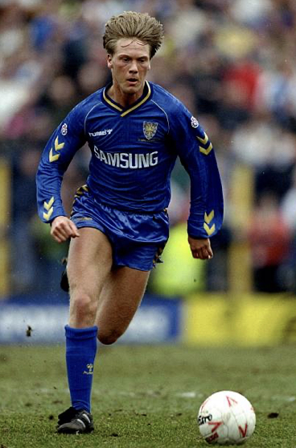
WARREN BARTON – 192 GAMES – 11 GOALS – 4 INTERNATIONALS
Warren Barton joined Wimbledon from Maidstone United in 1990. The £300,000 paid was the highest fee paid for a 4th tier player at the time. Barton went straight into Wimbledon’s first team and was a regular from then on. He initially filled the right back position but during the managerial era of Joe Kinnear, Barton was moved to right midfield with great success. His marauding runs down the right brought him to the attention of wealthier clubs and in June 1995 he joined Newcastle United who were managed by Kevin Keegan at the time. The fee £4 million made him the most expensive defender in the league.
It appeared that he would soon be capped by England but he debuted for the national team in 1995 in the game in Dublin that was abandoned following significant crowd disturbances. However , Barton did go on to win two further caps later that year. He left Newcastle for Derby County in 2002 but the Rams had a disastrous season ending in relegation and Barton then moved to QPR where he played a handful of games. Sadly he then made a decision that blights his reputation with many supporters of Wimbledon FC . By 2003-4 the team called Wimbledon FC but with no connection with SW19 or indeed South London was playing at the National Hockey Stadium, having been granted permission to play in Milton Keynes. Barton joined them and played a handful of games before departing. What happened next is well known, but by then Barton was gone. After some coaching for Dagenham & Redbridge, he relocated to the USA where he has forged a coaching career and regular media work for Fox Sports1 where he commentates on Premiership football.

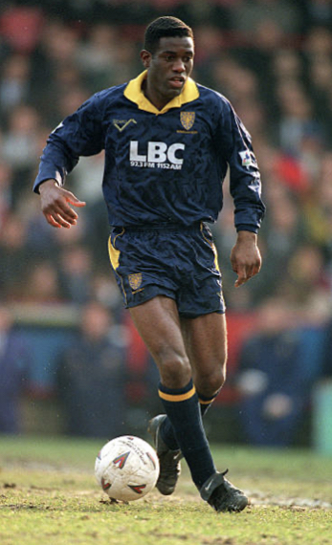
ROBBIE EARLE – 350 GAMES – 76 GOALS – 8 INTERNATIONALS
That Robbie Earle spent nine years at Port Vale making nearly 300 appearances for the club is something of a mystery. Fortunately Wimbledon saw what other top flight clubs had missed and he signed for £775,000 in July 1991. To say that Robbie Earle was probably the best signing made during Wimbledon’s fourteen seasons in the top division is a view held by many Dons supporters. A box to box midfield player, whose timing into opponents penalty area was immaculate allowing him to head a number of vital goals. None more so than in January 1997 when Earle rose to head a vital late equaliser in an FA Cup tie at Old Trafford.
Under Joe Kinnear he was made club captain and he captained the team to two cup semi-finals in 1997. In 2000, returning from injury, he took part in a reserve fixture and sustained a stomach injury that was diagnosed as a ruptured pancreas. It caused an extreme loss of weight and breathing difficulties, and it forced his retirement from the game. Born in England he was overlooked by England managers, arguably because he did not play for more fashionable clubs. Fortunately his parents were Jamaican born and this allowed him to play for them in the 1998 World Cup. His goal in a 3-1 defeat by Croatia, was the first goal scored by both Jamaica and by a Wimbledon player at the World Cup.
In 1999 he was awarded the MBE for services to football. Since retirement Robbie Earle has been a football journalist & commentator working primarily in the USA where he offers expert analysis of the English Premier League. He visited AFCWimbledon on a stay back in the UK and recently paid a visit to the Plough Lane stadium.

