TICKET RESALE

Listing ticket for sale:
- Go to ‘Account’ and select ‘Resell Tickets’
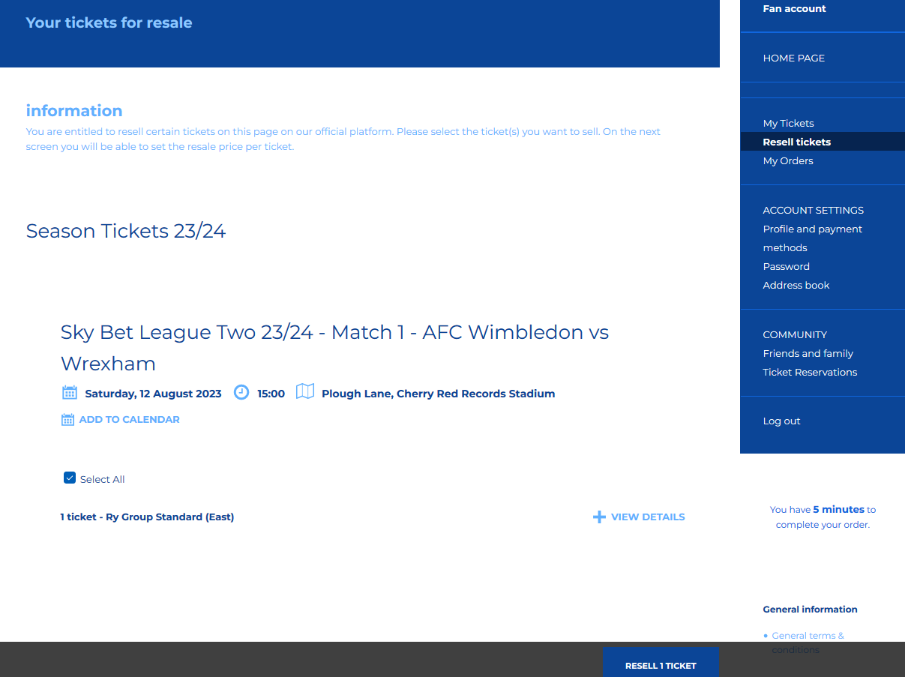

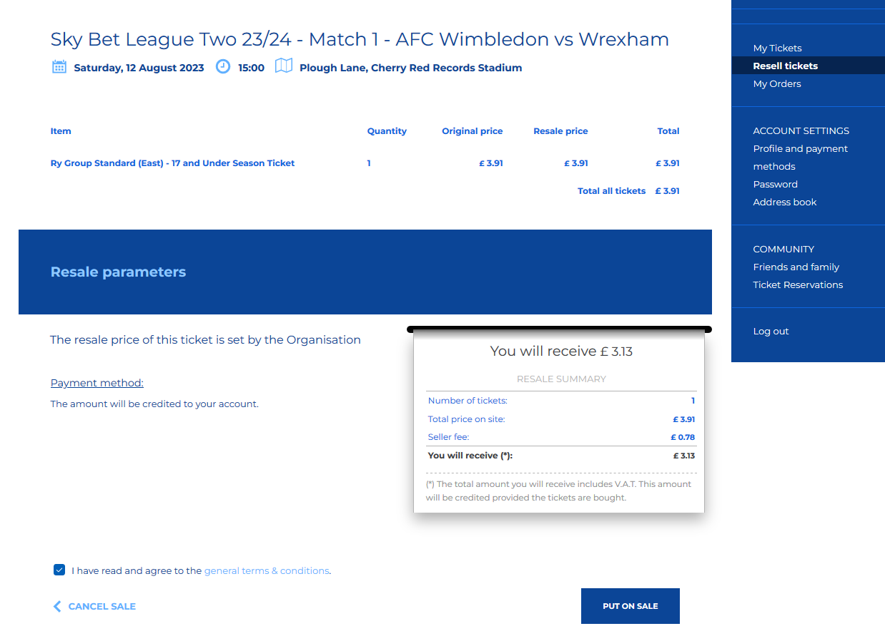

- It will show how much you will receive back as credit to your online account. If happy, select ‘put on sale’
- You will then receive a ‘Success’ message followed by a confirmation email:
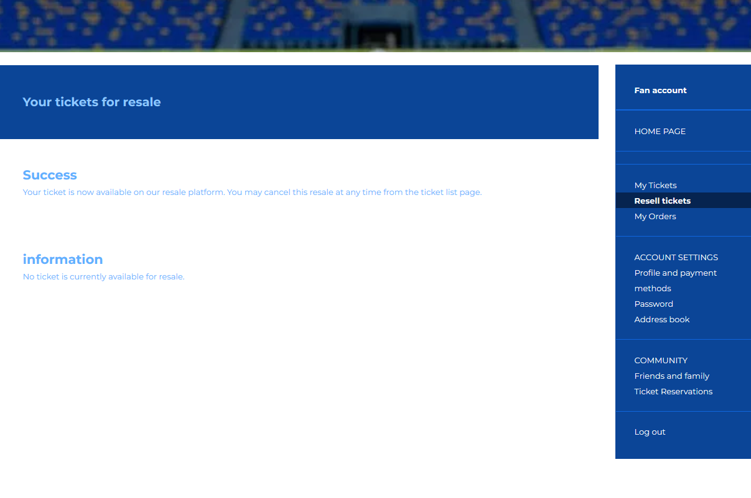
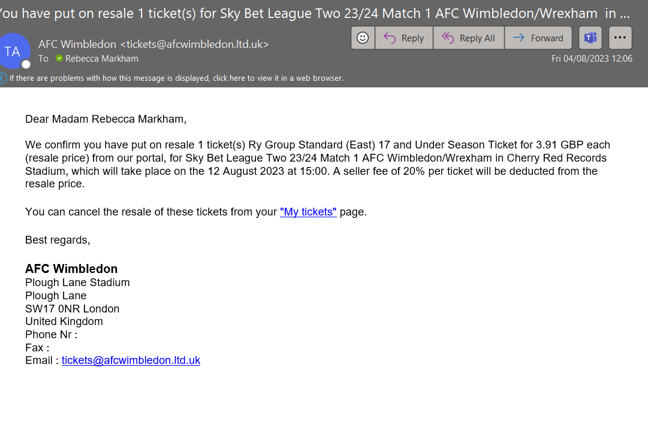

To cancel, go to ‘My Tickets’ on the ‘Account Sectiont’
- Select ‘cancel re-sale’
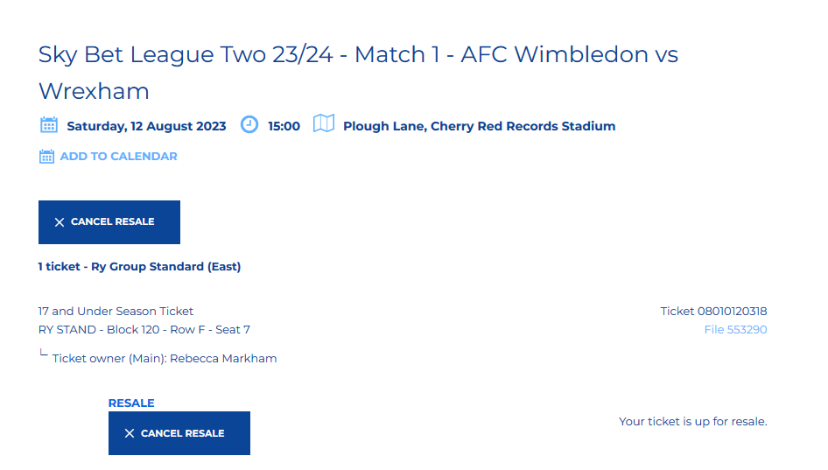

- You will then see the message confirming that the resale has been cancelled, followed by a confirmation email.
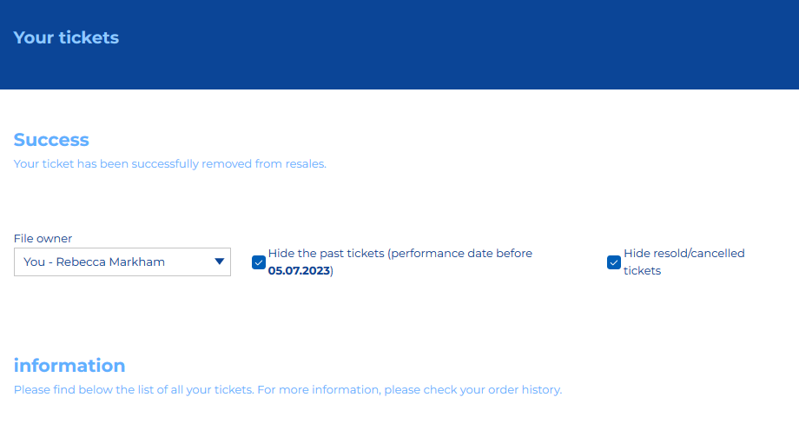
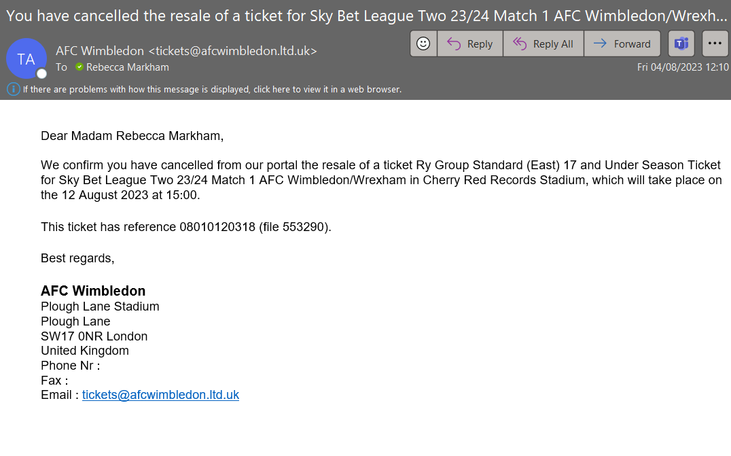

To buy, select ‘Ticket Resale’ on the ticketing page:

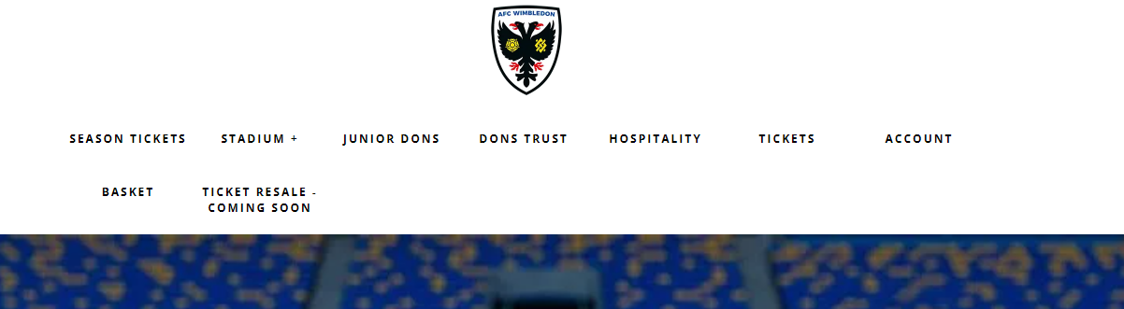

- Available games will show, select ‘Buy’ to purchase.

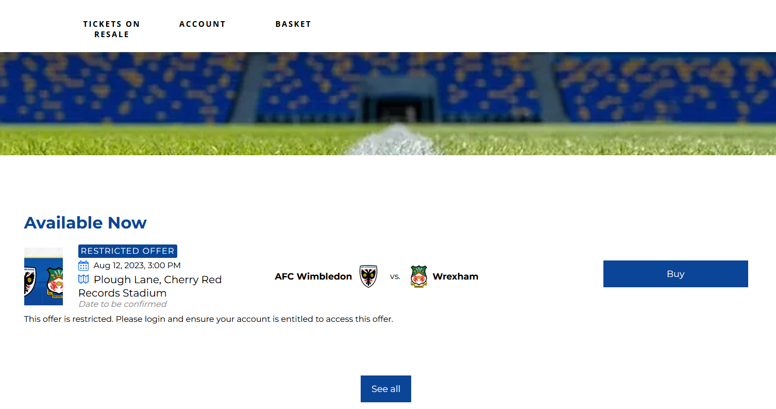
- Select your seat from available seats on the seat map:
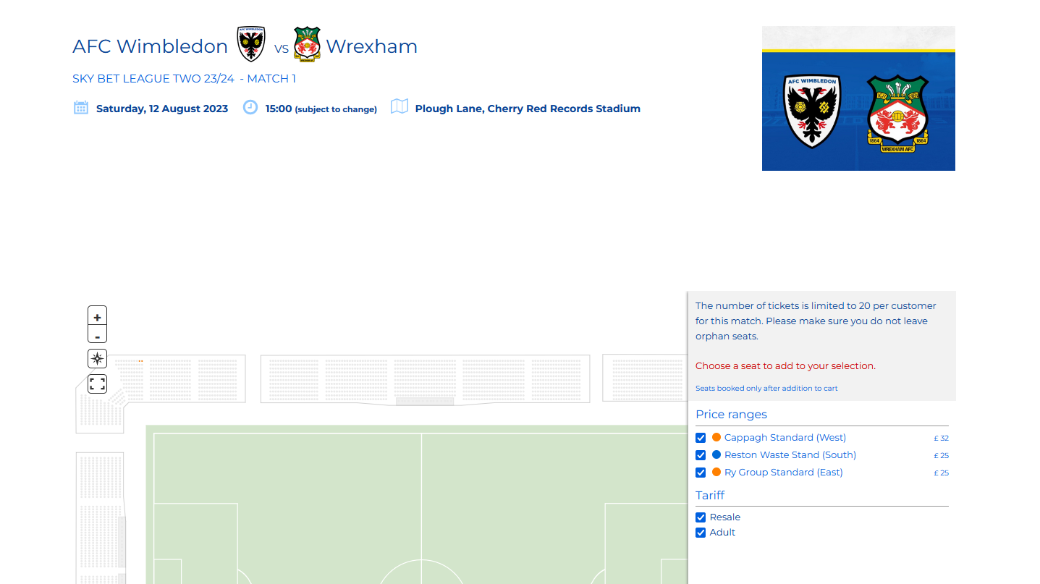

- Please note tickets will only be available at the Adult rate:
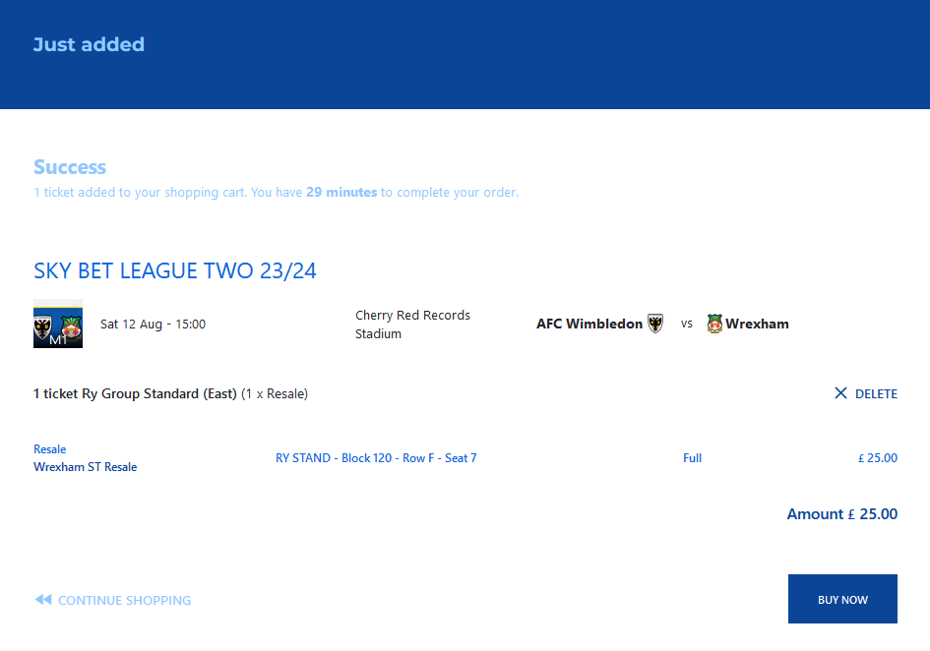
- Once purchased you will receive an order number and confirmation email as normal:
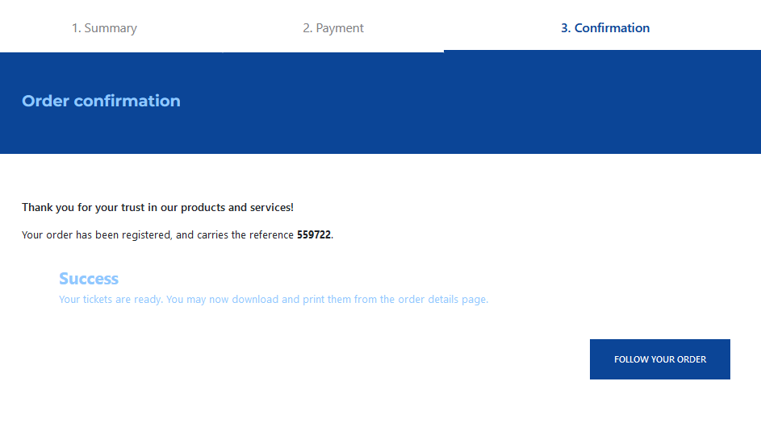
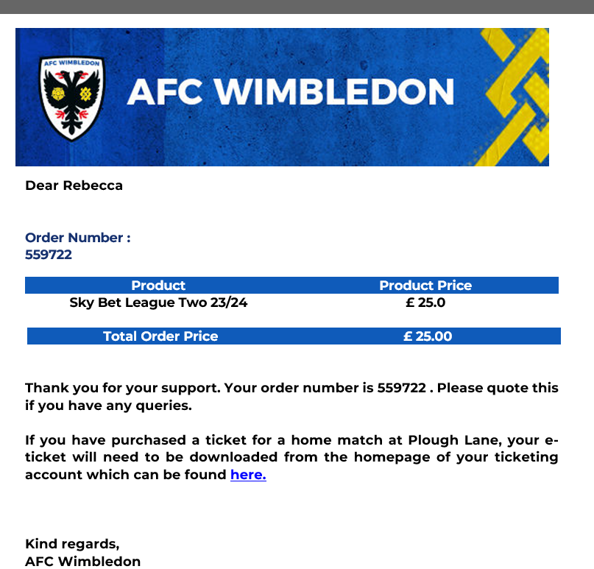

- For listed tickets that have been purchased, the following email will be received:
